**Spaceology- A Glimpse of Space for Beginners**

**A PROJECT REPORT**

***Submitted by***

ABHAY BAJPAI

***in partial fulfillment for the award of the degree***

***of***

**B.TECH. (CSE - ARTIFICIAL INTELLIGENCE AND MACHINE LEARNING)**



**Lovely Professional University, Punjab**

**NOVEMBER 2024**

**Lovely Professional University, Punjab**

**BONAFIDE CERTIFICATE**

Certified that this project report **“Spaceology- A Glimpse of Space for Beginners”** is the bonafide work of “ABHAY BAJPAI**”** who carried out the project work under my supervision.

<<Signature of the Supervisor>>  
**SIGNATURE**<<Name>>

**SUPERVISOR**

<<Full address of the Deptt. & Organization >>

<<Signature of the Mentor>>

**SIGNATURE**

<<Name>>  
**CLASS MENTOR**

<<Signature of the Head of the Department>>

**SIGNATURE**

<<Name>>  
**HEAD OF THE DEPARTMENT**

**INDEX**

|  |  |  |
| --- | --- | --- |
| **CHAPTER NO.** | **CHAPTER NAME** | **PAGE NO.** |
| **1** | **TITLE PAGE** | **i** |
| **2** | **BONAFIDE CERTIFICATE** | **ii** |
| **3** | **INDEX** | **iii** |
| **4** | **INTRODUCTION** | **iii** |
| **5** | **TECHNOLOGY USED** | **iv** |
| **6** | **WORKFLOW** | **v** |
| **7** | **WORKING OF THE PROJECT** | **vi-vii** |
| **8** | **CODE SNIPPETS OF THE PROJECT** | **viii** |
| **9** | **SCREENSHOTS** | **ix** |
| **10** | **CONCLUSION** | **x** |
| **11** | **REFERENCE** | **x-xi** |

**INTRODUCTION:-**

Spaceology is an interdisciplinary field that explores the vastness of space, encompassing the study of celestial bodies, cosmic phenomena, and the universe's underlying principles. This intriguing domain combines elements of astronomy, astrophysics, planetary science, and even philosophy, delving into questions about the nature of existence, the formation of galaxies, and the possibility of extraterrestrial life.

As humanity continues to advance technologically, our ability to observe and understand space has grown exponentially. Spaceology not only examines the physical characteristics of planets, stars, and galaxies but also investigates the potential for human exploration and colonization of other worlds. The field fosters curiosity and wonder, inviting individuals to contemplate our place in the cosmos and the profound implications of space exploration for science, culture, and society.

In recent years, the emergence of private space enterprises and international collaborations has further propelled interest in spaceology, making it a relevant and dynamic area of study. Through the integration of research, education, and public engagement, spaceology aims to inspire the next generation of scientists, engineers, and explorers who will continue to push the boundaries of our understanding of the universe.

This introduction sets the stage for a deeper exploration of the fundamental aspects of spaceology, including its history, key concepts, and future prospects, ultimately highlighting its significance in a world increasingly focused on the stars.

**TECHNOLOGY USED:-**

• **HTML (HyperText Markup Language)**:

* HTML is the backbone of the website, providing the structure and content. It defines elements like headers, sections, images, forms, and links.

• **CSS (Cascading Style Sheets)**:

* CSS is used for styling the website, including layout, colors, fonts, and responsive design. It enhances the visual appeal of the site and ensures a consistent look and feel across different devices.

• **JavaScript (Optional)**:

* While not explicitly used in the provided code, JavaScript can enhance interactivity and functionality (e.g., form validation, dynamic content updates). It's commonly used for handling user interactions and creating a more engaging user experience.

• **YouTube API (Optional)**:

* If you want to dynamically embed videos or manage video content from YouTube, you could use the YouTube API, but in this case, a simple iframe is used to embed a video.

**WORKFLOW: -**

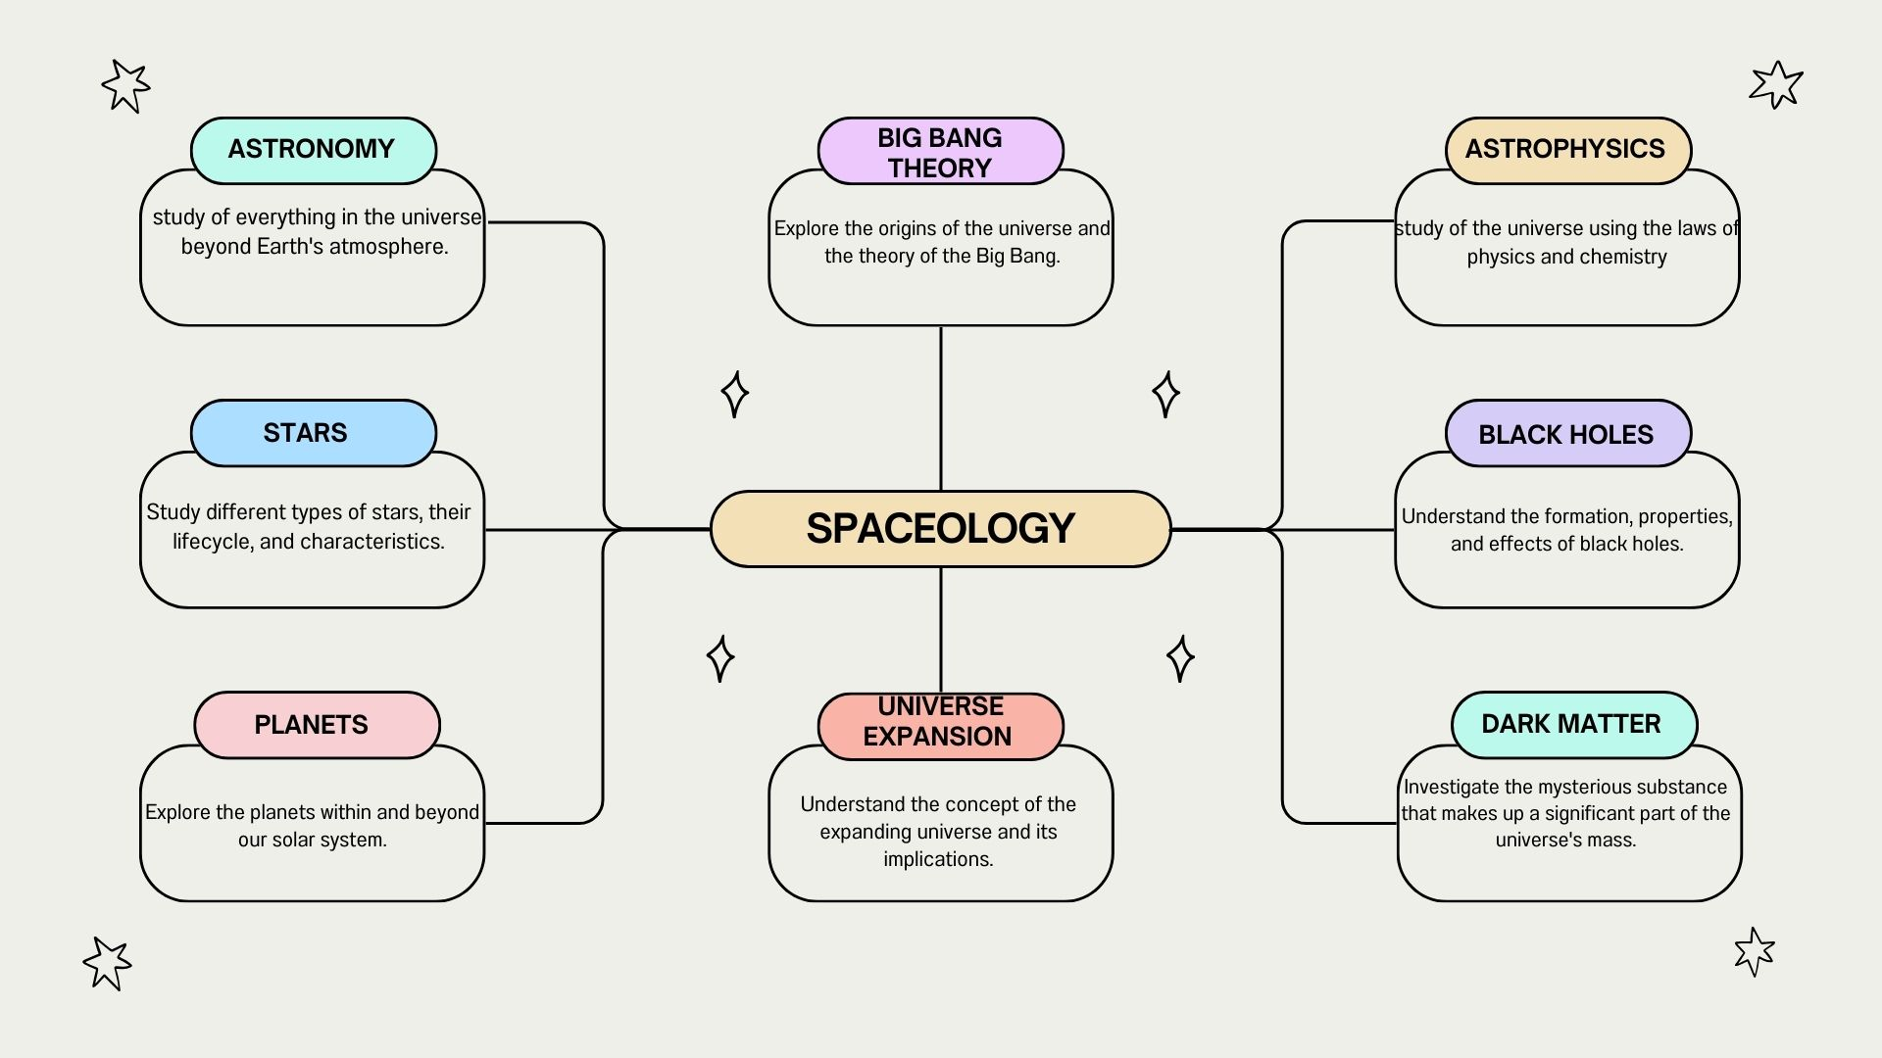

**WORKING OF THE PROJECT**

**Objective:** The main goal of the Spaceology project is to create an informative, engaging, and visually appealing website that explores various topics related to space science, including astronomy, astrophysics, space exploration, and cosmology.

**1. Setup and Initial Planning:**

**Project Scope:**

* Define the target audience (students, space enthusiasts, general public).
* Outline the key topics to cover: Astronomy, Astrophysics, Space Exploration, Cosmology.

**Research:**

* Gather reliable sources of information (NASA, scientific journals, books, documentaries).
* Identify key topics and subtopics within each branch of space science.

**2. Content Creation:**

**Astronomy Section:**

* **Stars:** Explain different types of stars, their lifecycle, and characteristics.
* **Planets:** Discuss planets in our solar system and beyond, focusing on unique features and discoveries.

**Astrophysics Section:**

* **Black Holes:** Provide an overview of black holes, their formation, and their impact on space-time.
* **Dark Matter:** Explore the concept of dark matter and its significance in the universe.

**Space Exploration Section:**

* **Space Missions:** Highlight significant space missions (Apollo, Mars Rover, ISS).
* **Space Technology:** Discuss advancements in space technology and their applications.

**Cosmology Section:**

* **Big Bang Theory:** Explain the origins of the universe and the theory of the Big Bang.
* **Universe Expansion:** Discuss the concept of the expanding universe and its implications.

**3. Design and Development:**

**Website Structure:**

* Create a detailed site map outlining the main sections and subsections.
* Design wireframes and mockups for each page, focusing on user experience and navigation.

**HTML and CSS:**

* **HTML:** Write the HTML code to structure the content, including semantic tags for better accessibility and SEO.
* **CSS:** Apply styles to enhance the visual appeal, including layout, typography, colors, and animations.

**Responsiveness:**

* Use media queries to ensure the website looks good on all devices (desktop, tablet, mobile).

**4. Interactive Elements and Multimedia:**

**Images and Videos:**

* Include high-quality images of celestial bodies, space missions, and astronomical phenomena.
* Embed informative videos, such as documentary clips and NASA footage.

**Interactive Features:**

* **Planet Cards:** Implement hover effects and animations to make the planet cards interactive.
* **YouTube Videos:** Embed videos with proper attributes for responsiveness and user control.

**5. Testing and Optimization:**

**Testing:**

* Conduct cross-browser testing to ensure compatibility with all major browsers (Chrome, Firefox, Safari, Edge).
* Perform usability testing with a sample audience to gather feedback and identify areas for improvement.

**Optimization:**

* Optimize images and videos for faster loading times.
* Minify CSS and JavaScript files to reduce file size and improve performance.

**6. Deployment and Promotion:**

**Deployment:**

* Choose a reliable hosting service and deploy the website.
* Ensure the domain name is relevant and easy to remember.

**Promotion:**

* Use social media platforms to promote the website.
* Collaborate with space-related communities and organizations for wider reach.

**7. Maintenance and Updates:**

**Regular Updates:**

* Continuously update the content to include new discoveries and advancements in space science.
* Monitor website performance and user feedback to make necessary improvements.

**Engagement:**

* Add a blog or news section to keep the audience engaged with the latest space-related topics and events.

**Code snippets: -**

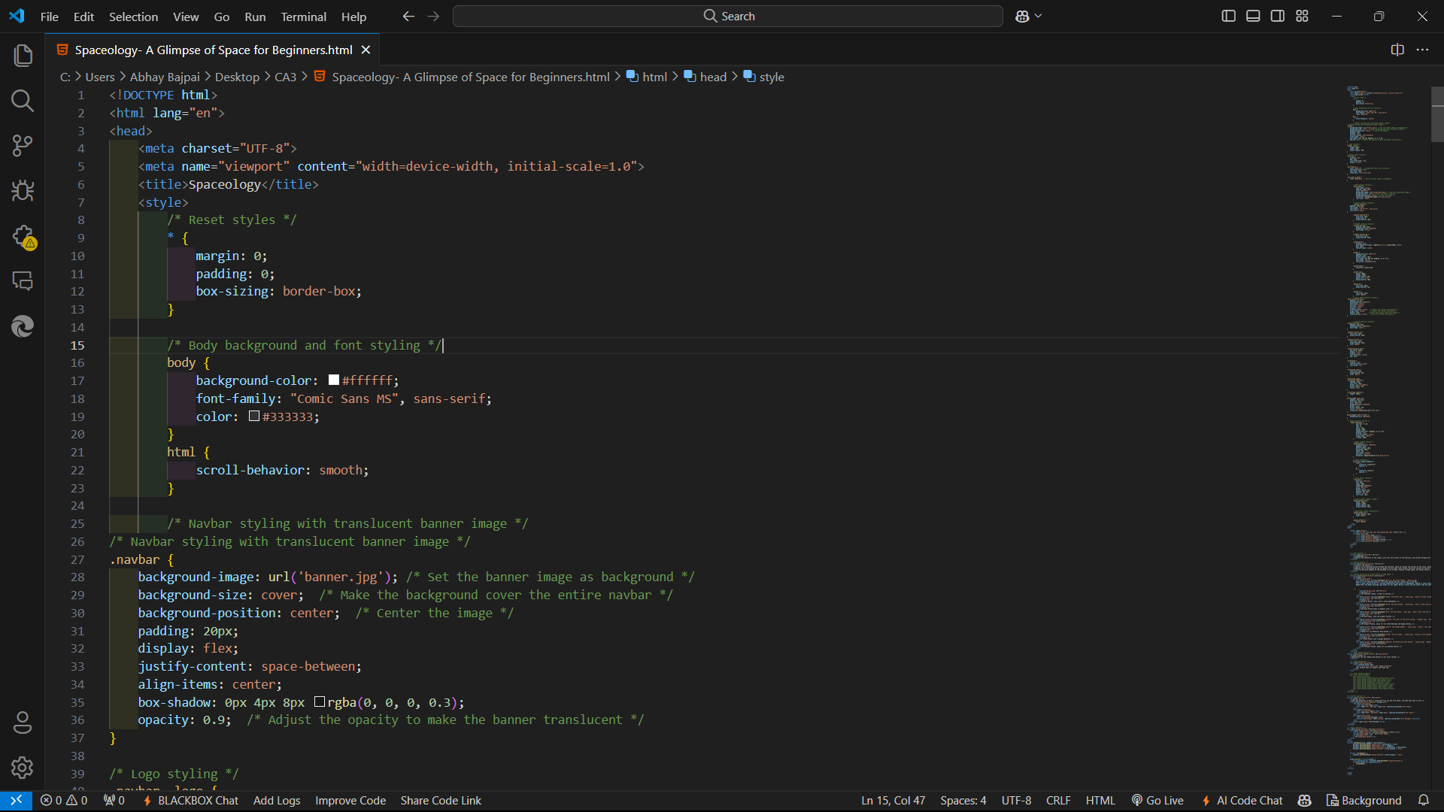

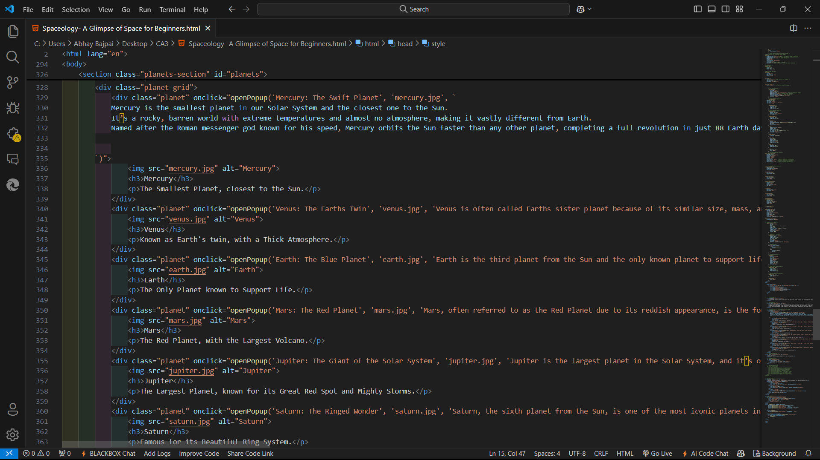

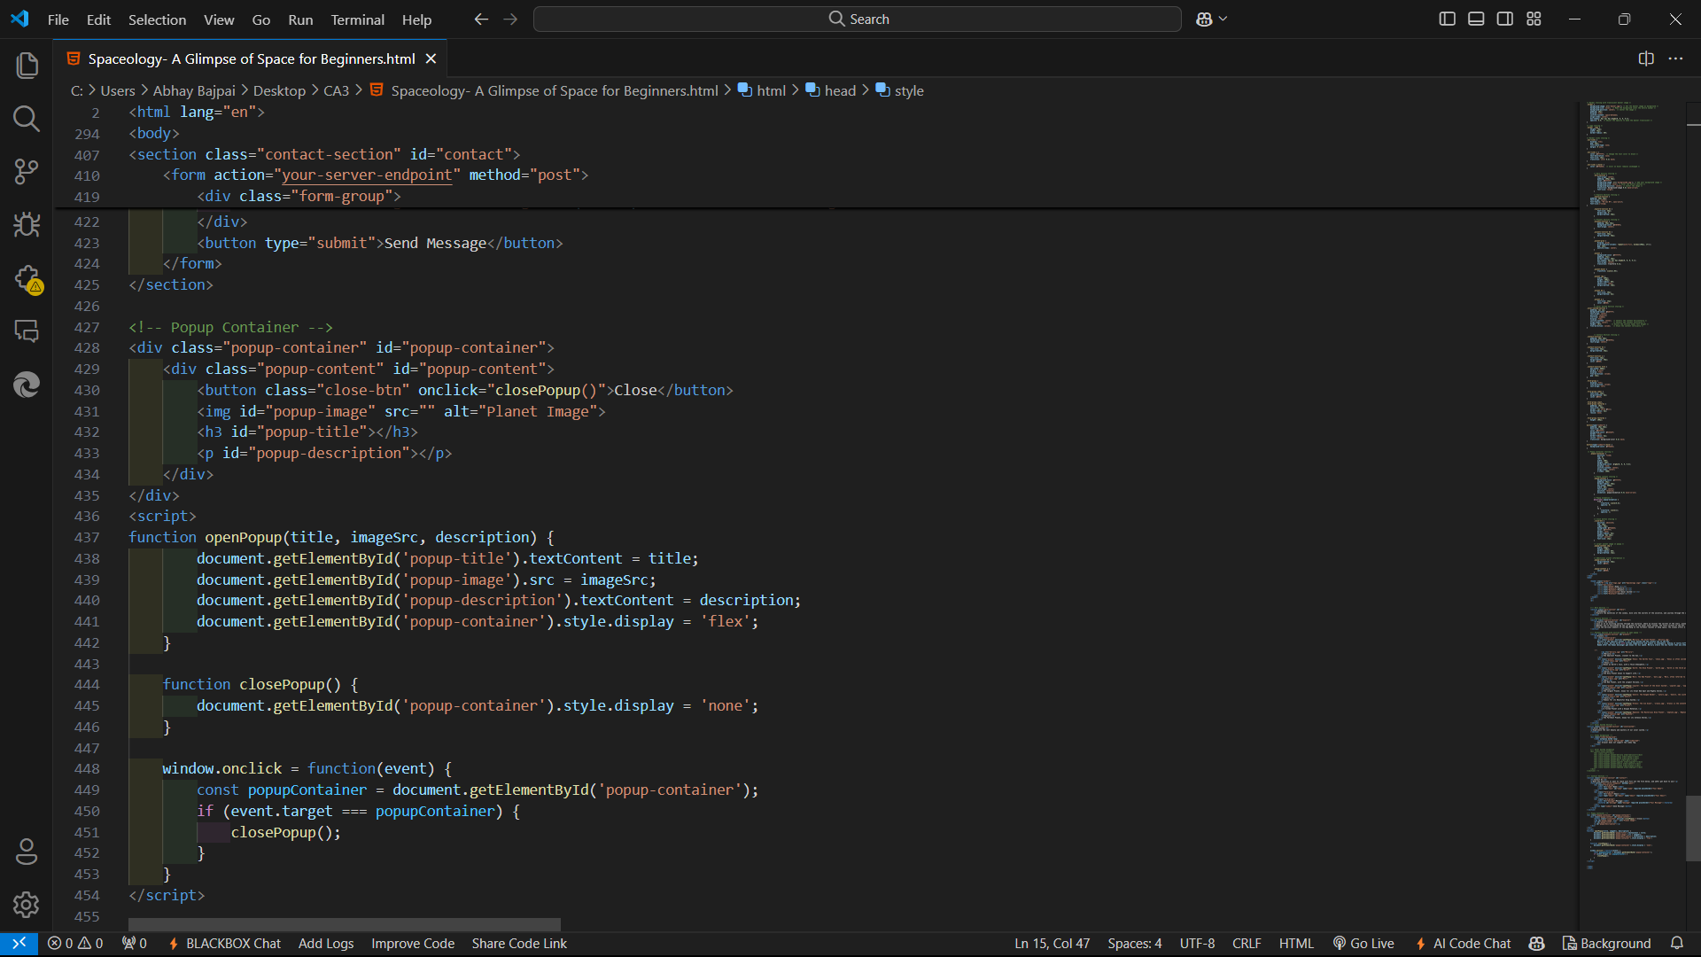

**SCREENSHOTS:-**

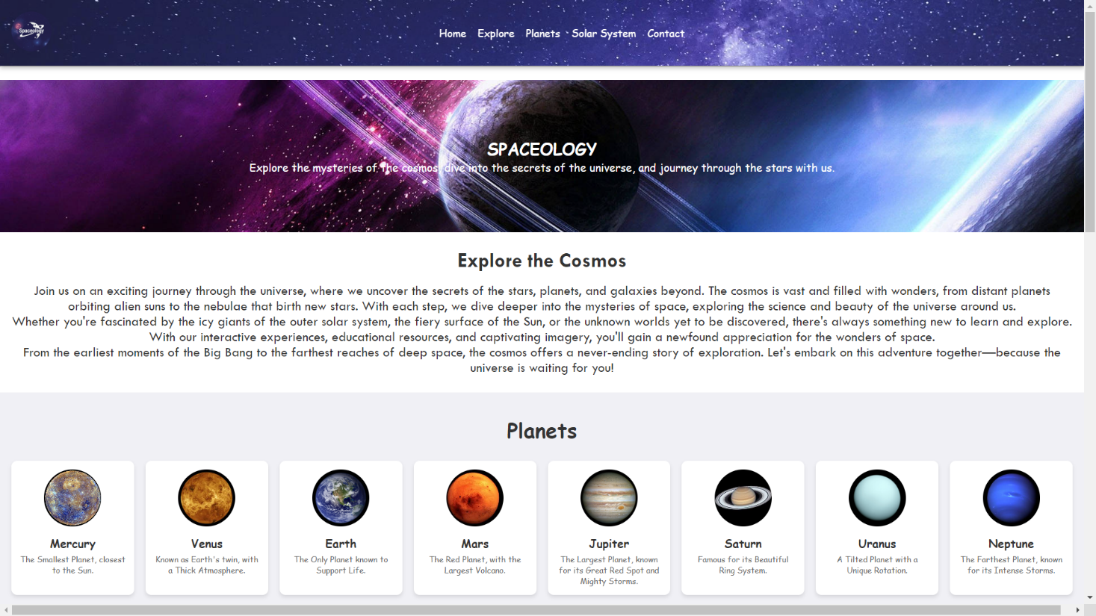

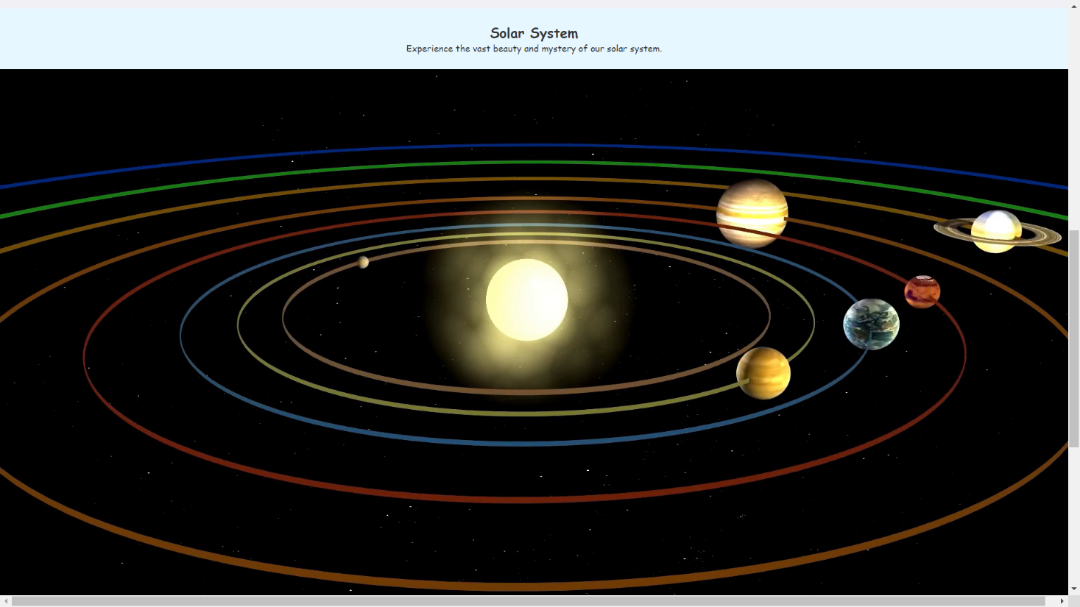

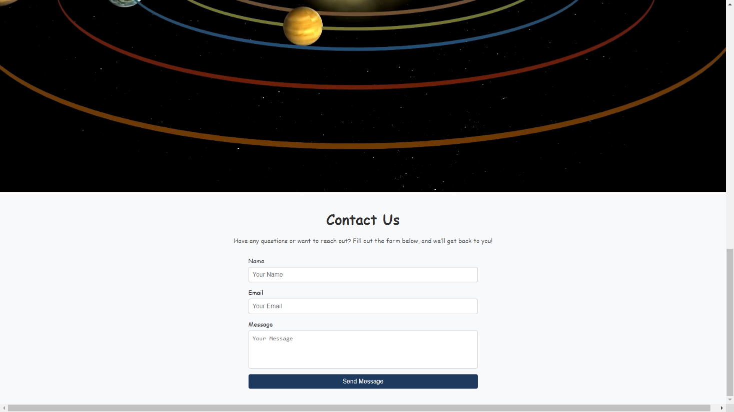

**CONCLUSION**

The Spaceology project is designed to serve as a comprehensive and engaging educational platform, providing users with a thorough exploration of various space science topics. Covering branches such as astronomy, astrophysics, space exploration, and cosmology, it aims to ignite curiosity and expand the knowledge of its audience. Through a well-structured workflow, the project focuses on creating a visually appealing and interactive website that is accessible on various devices. It incorporates high-quality images, informative videos, and user-friendly design to enhance the learning experience. By continuously updating its content with the latest discoveries and advancements, the Spaceology project remains a valuable and dynamic resource for students, space enthusiasts, and the general public, fostering a deeper appreciation for the mysteries and wonders of the universe. This project not only educates but also inspires its users, making space science accessible and enjoyable for all.

**REFERENCES**

Mozilla Developer Network (MDN). (n.d.). *HTML, CSS, and JavaScript Documentation*. Retrieved from <https://developer.mozilla.org>

W3Schools. (n.d.). *Web Development Tutorials*. Retrieved from <https://www.w3schools.com>

React Documentation. (n.d.). *Building Interactive UIs with React*. Retrieved from https://reactjs.org/docs

MongoDB. (n.d.). *MongoDB Documentation*. Retrieved from <https://www.mongodb.com/docs>

Adobe XD & Figma Tutorials. (n.d.). *Designing User Interfaces for Web Projects*. Retrieved from <https://www.adobe.com/xd> and <https://www.figma.com>

**Additional References:**

1. **Bootstrap Documentation**. (n.d.). *Building Responsive Web Pages*. Retrieved from https://getbootstrap.com/docs
   * A resource for using Bootstrap, a front-end framework that simplifies creating responsive, mobile-first web designs.
2. **Node.js Documentation**. (n.d.). *JavaScript Runtime for Backend Development*. Retrieved from https://nodejs.org/en/docs
   * Provides guidance on using Node.js for server-side development, essential for managing gallery data and handling user requests.
3. **SQL Tutorial** (n.d.). *SQL Basics and Database Management*. W3Schools. Retrieved from https://www.w3schools.com/sql/
   * A tutorial for learning SQL, important for setting up and managing databases for storing artwork and artist information.
4. **Jakob Nielsen’s Usability Heuristics**. (1995). *10 Usability Heuristics for User Interface Design*. Nielsen Norman Group. Retrieved from https://www.nngroup.com/articles/ten-usability-heuristics/
   * Foundational principles on creating user-friendly interfaces, aiding in designing intuitive and accessible navigation for users of the gallery.

An example of a professional online art gallery, providing inspiration on layout, categorization, and presentation of art collections in a digital format.

1. **Virtual Reality in Art Museums**. (2022). *Using VR to Enhance Art Appreciation*. Journal of Art and Technology, 18(2), 45-57.
   * A journal article discussing the role of virtual and augmented reality in art galleries, providing insights into potential future enhancements for virtual art experiences.
2. **Web AIM**. (n.d.). *Accessibility for Web Developers*. Retrieved from <https://webaim.org/>
   * A comprehensive guide to making web content accessible for all users, crucial for ensuring the gallery meets inclusive design standards.
3. NASA (National Aeronautics and Space Administration)

https://www.nasa.gov/?form=MG0AV3